16) Summing up any n numbers and finding average

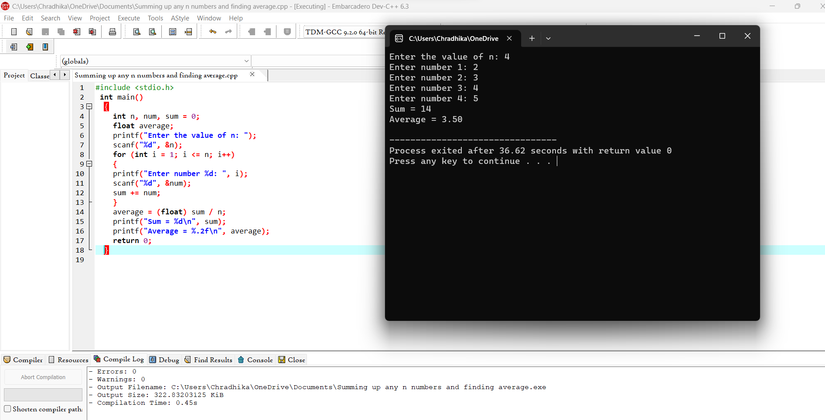

17) Printing digits of an integer number

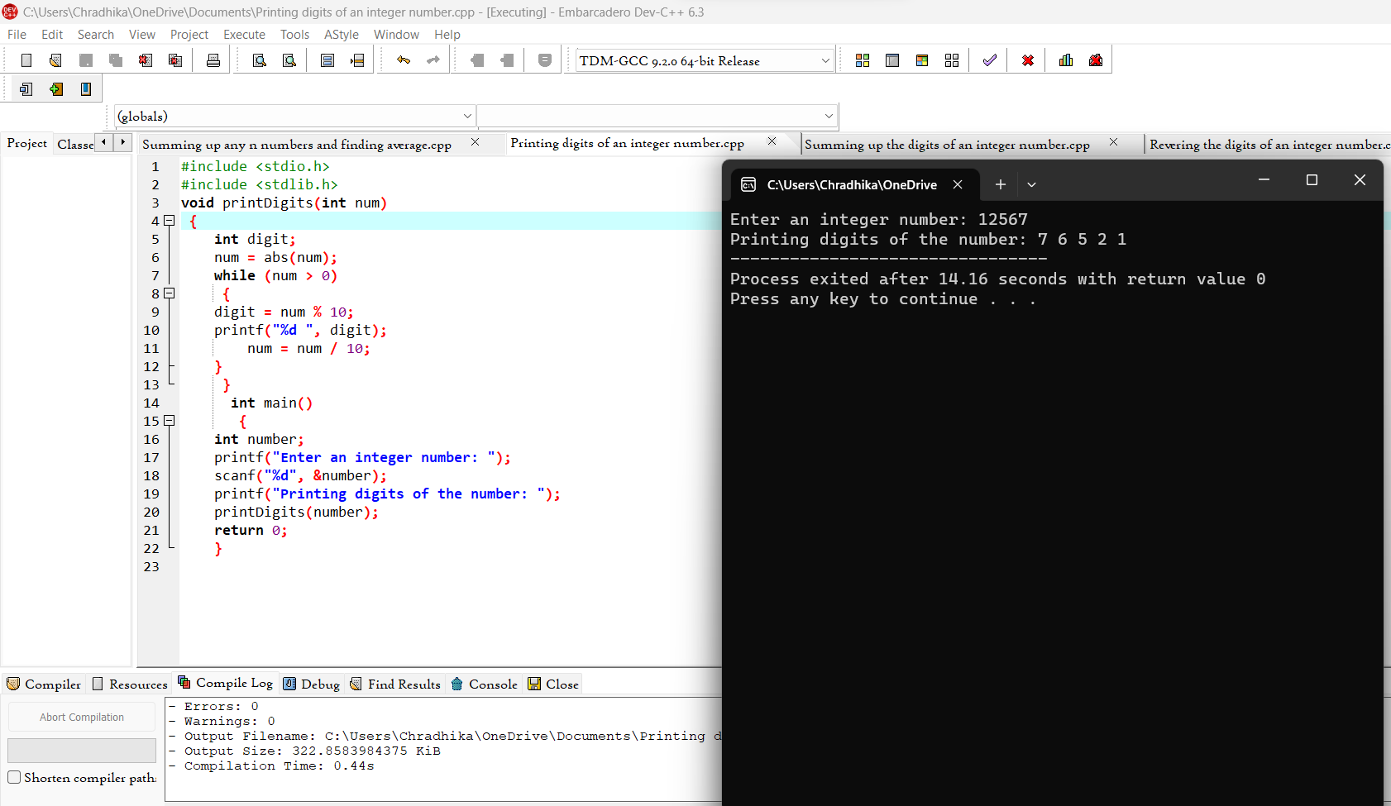

18) Summing up the digits of an integer number

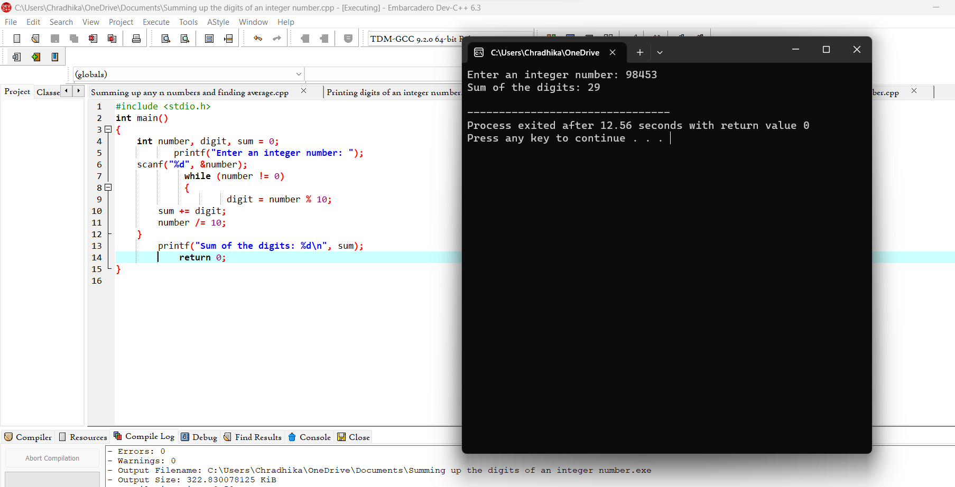

19) Revering the digits of an integer number

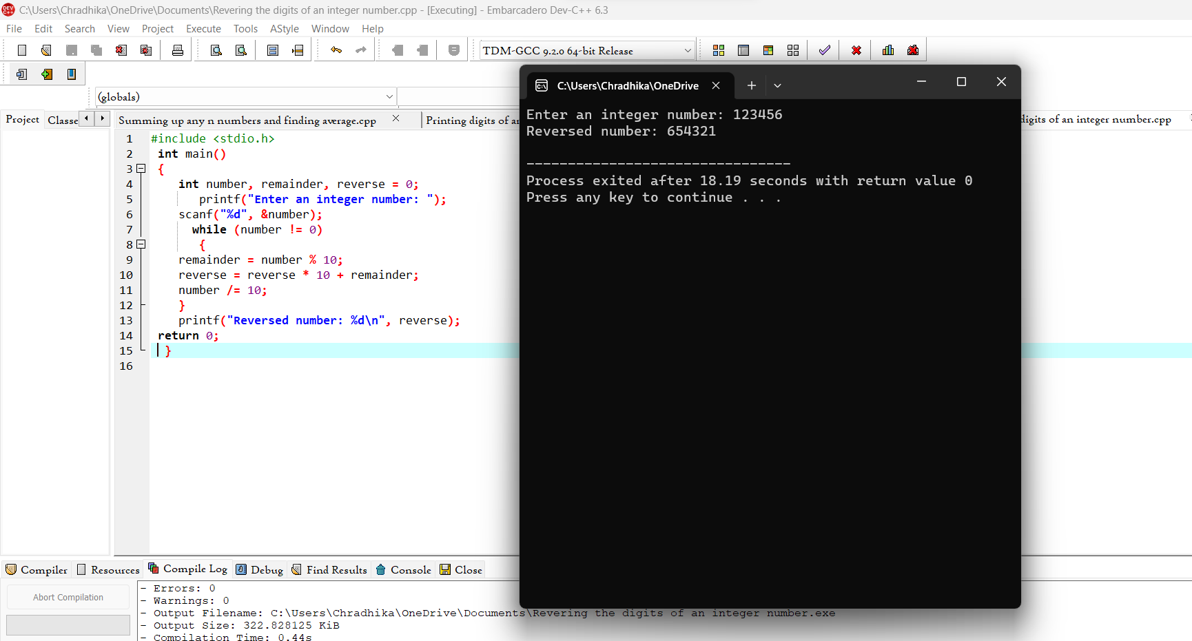

20) Finding whether the given integer is odd or even

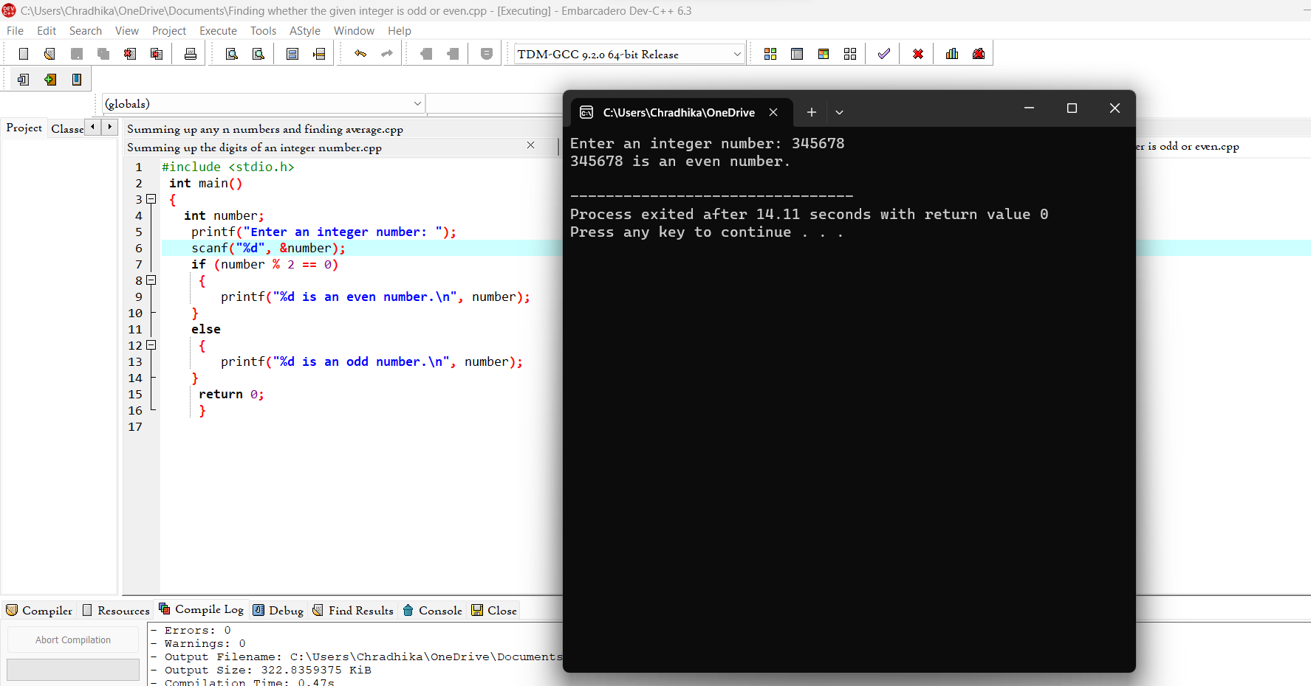

21) Finding the given integer is positive or negative

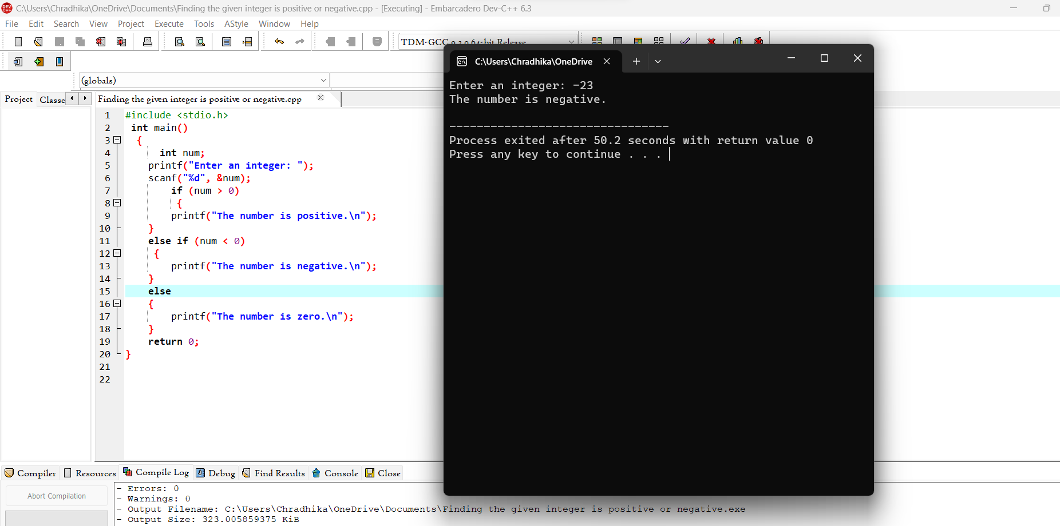

22) Swapping two numbers with a temporary variable

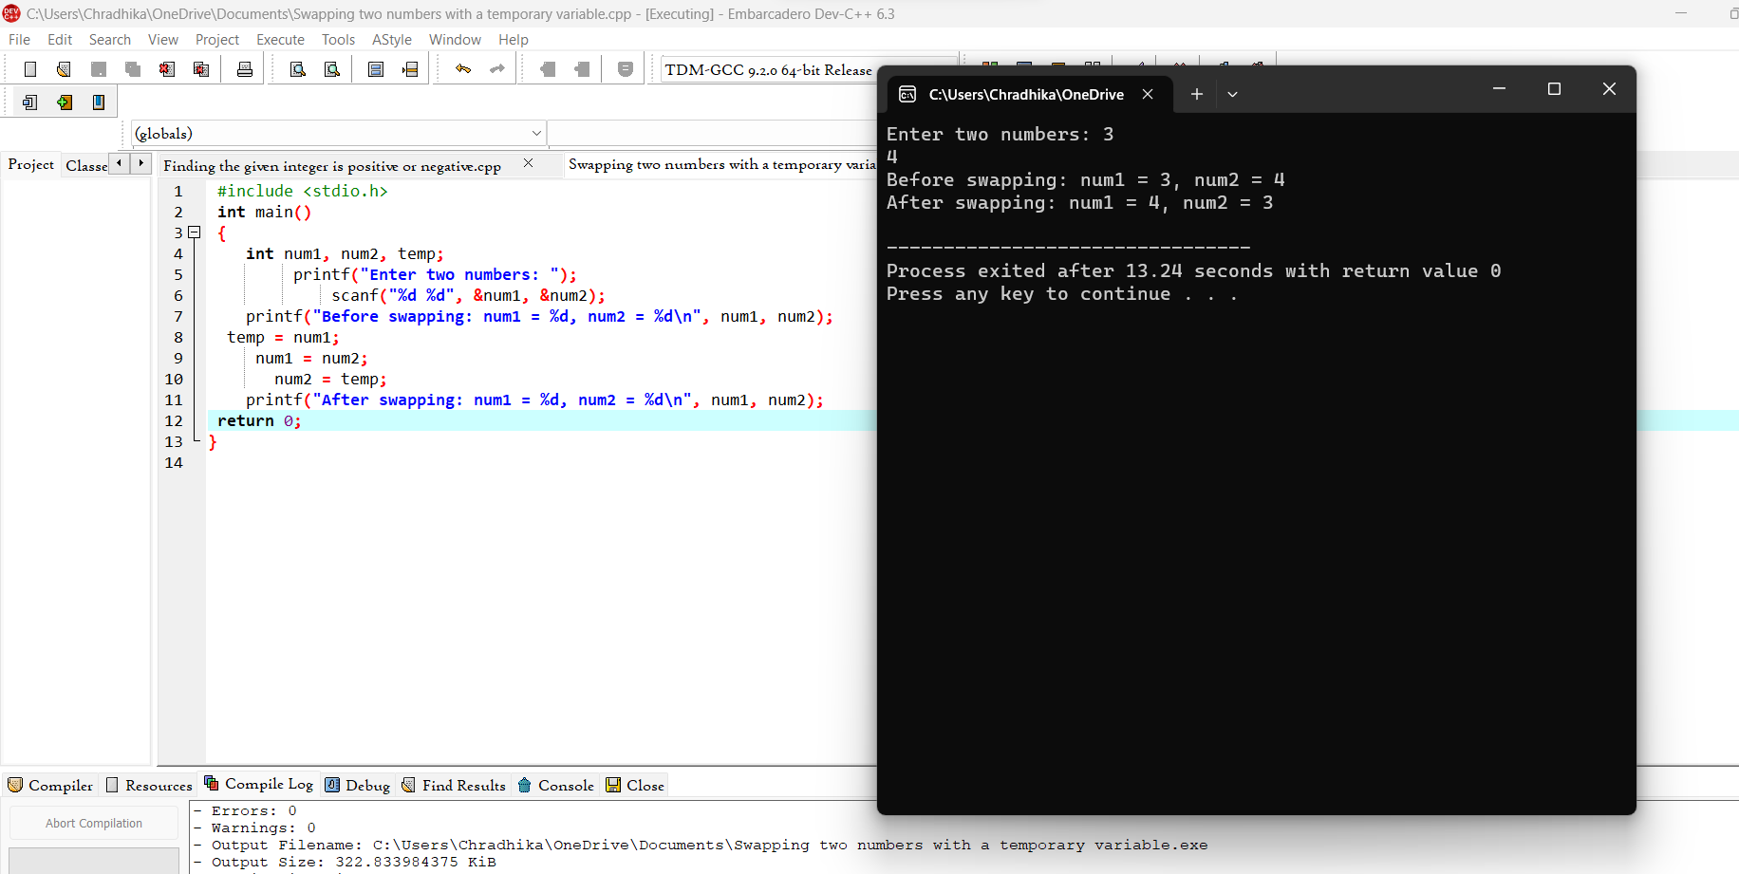

23) Swapping two numbers without a temporary variable

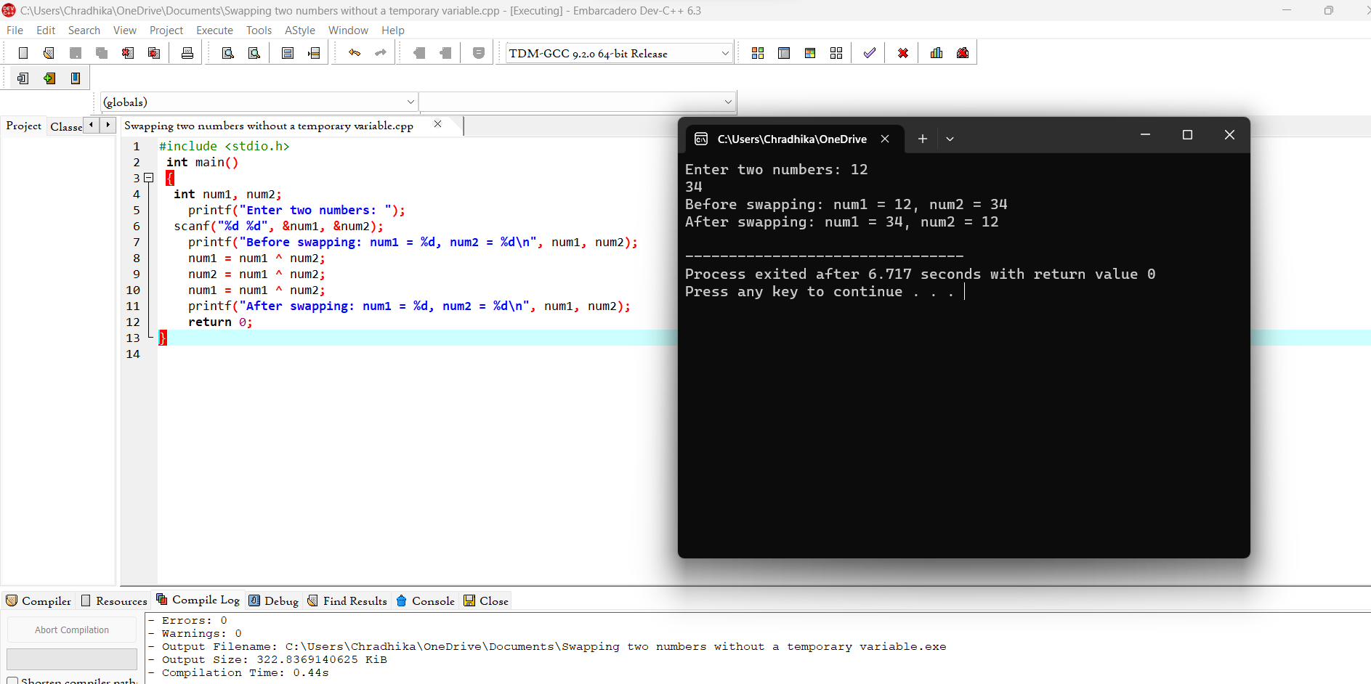

24) Swap 3 numbers a to b, b to c and c to a

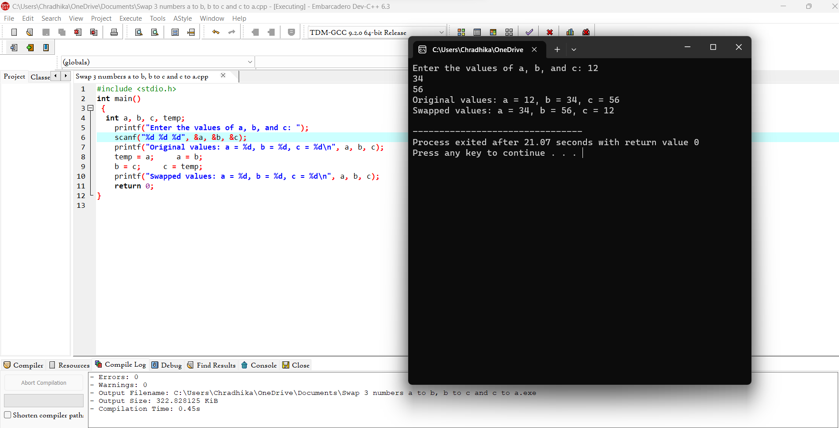

25) Finding the biggest out of 2 integer numbers

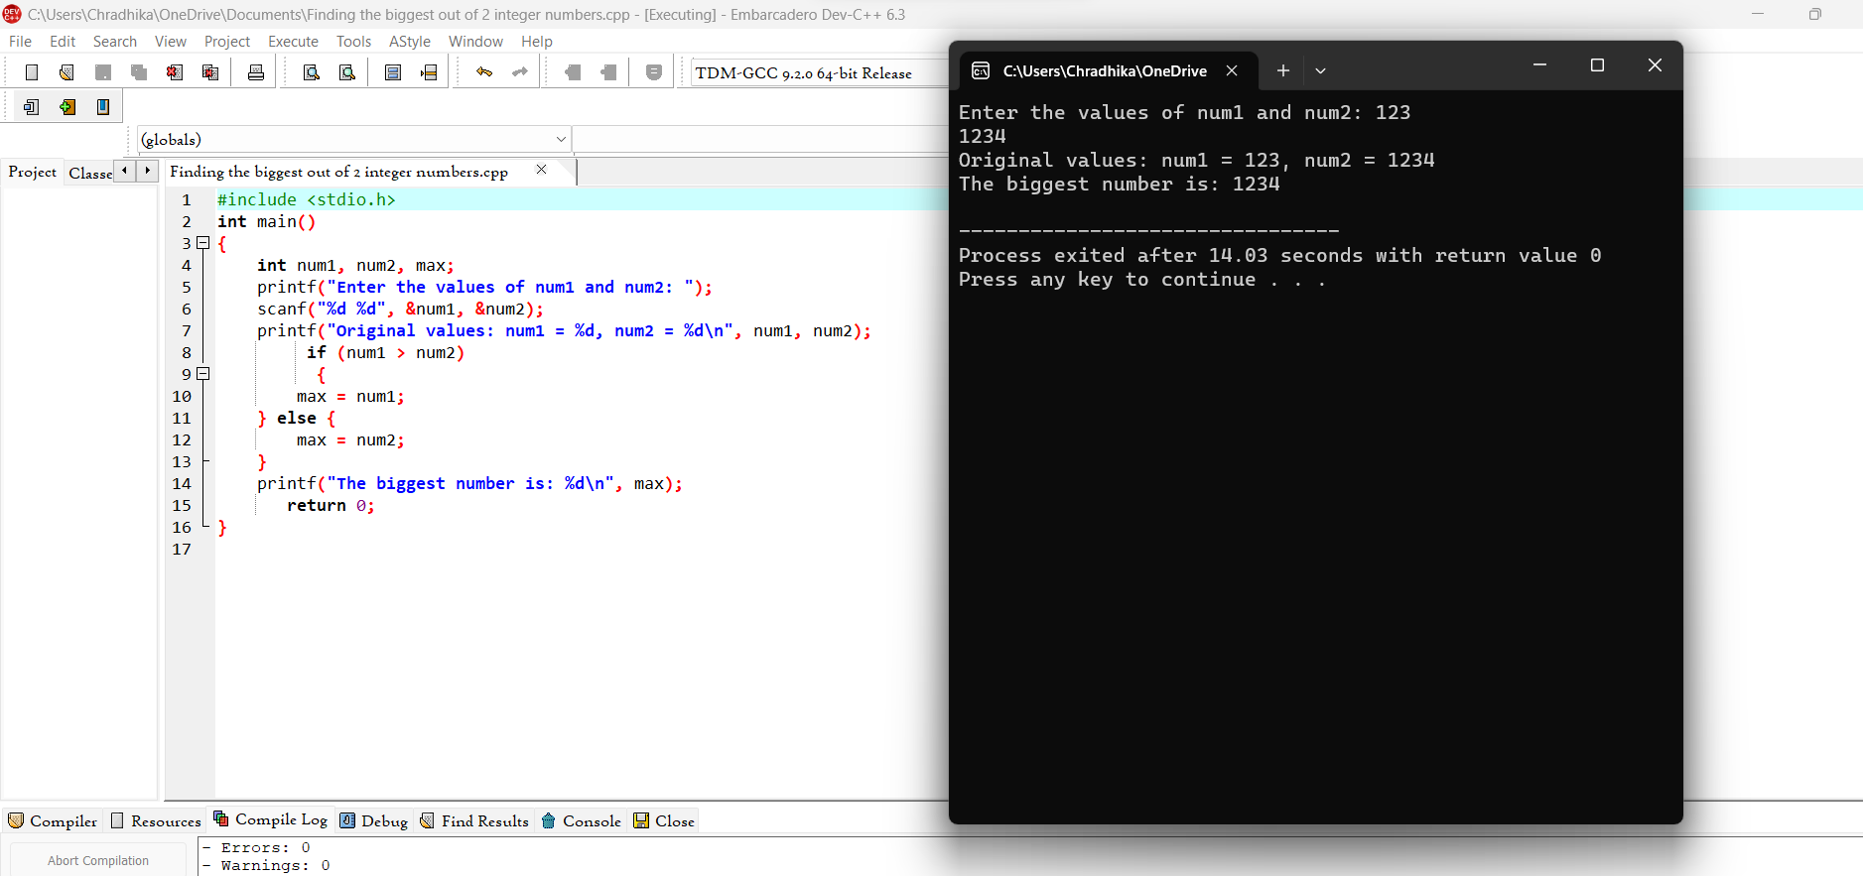

26) Finding the biggest out of n integers

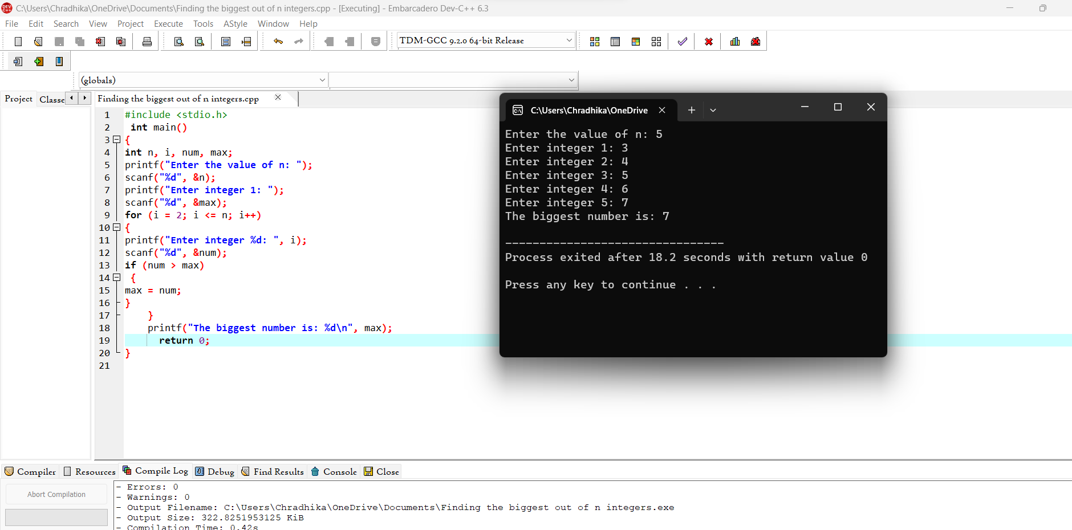

27) Sine series [sin(x) = x - x ^3 /3! + x^ 5 /5! – x^ 7 /7! . . . . . . ]

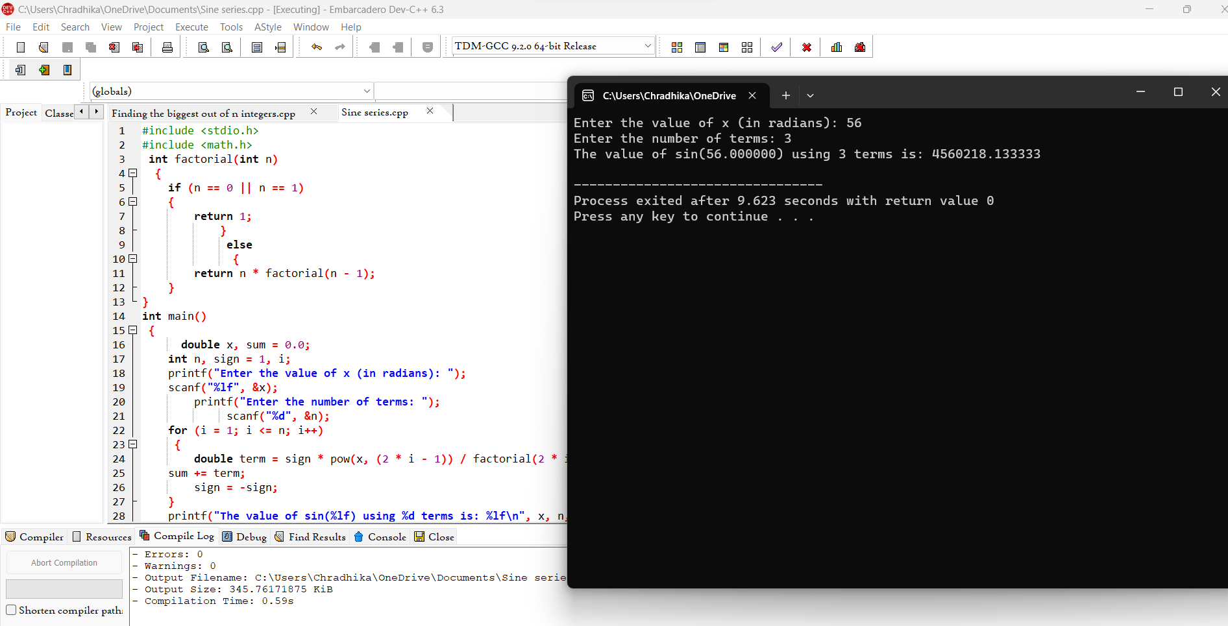

28) Cos series [cos(x) = 1 – x 2 /2! + x 4 /4! – x 6 /6! . . . . . . ]

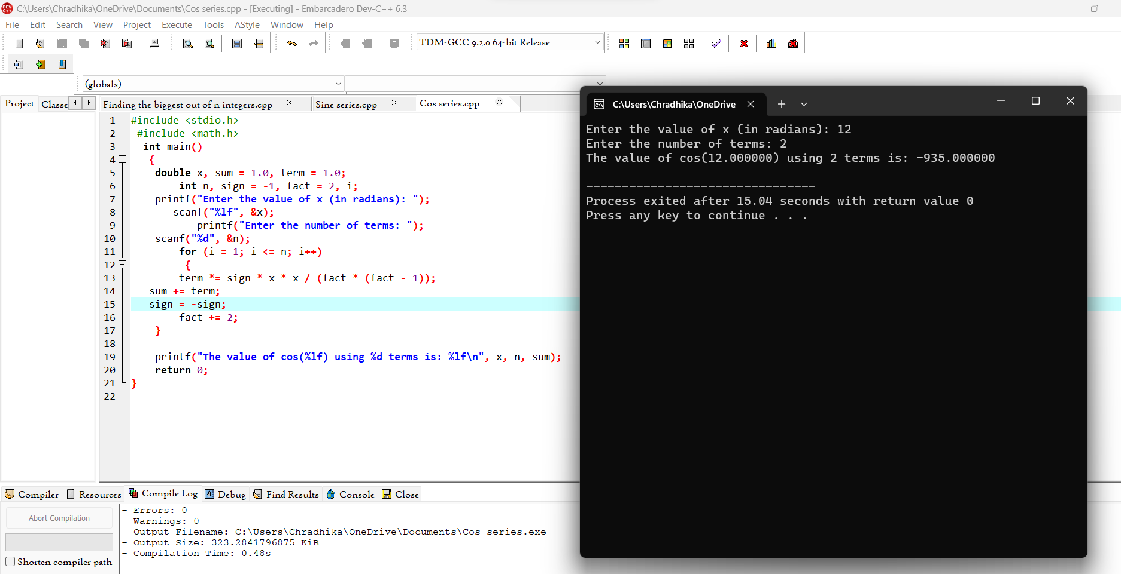

29) Exponential series [e -1 = 1 – x/1! + x 2 /2! – x 3 /3! + x4 /4! . . . . . . ]

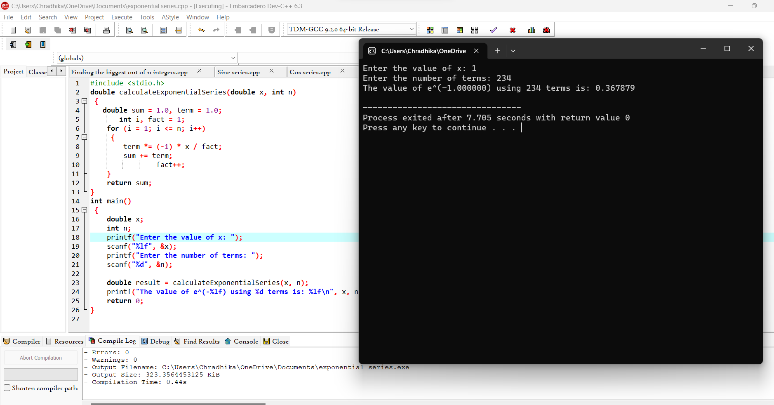

30) Linear Search

